**CP Club 365 Days Challenge**

**Programming language – C++**

**Problem Statement**

<https://www.codechef.com/problems/TABLET>

Git :- <https://github.com/Vedantbharad2603/CP_club_365_Days>

**Your Code**:

// 0x110Day of 0x365Days challenge

// VEDANT BHARAD

// 4-2-2023

#include <iostream>

using namespace std;

void myFun(int w[],int h[],int p[],int n,int b){

    int area=0;

    for(int i=0;i<n;i++)

    {

        if(p[i]<=b && area<(w[i]*h[i]))

        {

            area=w[i]*h[i];

        }

    }

    if(area==0)

    {

        cout<<"no tablet"<<endl;

    }else{

        cout<<area<<endl;

    }

}

int main() {

    int t;

    cin>>t;

    while(t--)

    {

        int n,b;

        cin>>n>>b;

        int w[n],h[n],p[n];

        for(int i=0;i<n;i++)

        {

            cin>>w[i]>>h[i]>>p[i];

        }

        myFun(w,h,p,n,b);

    }

    return 0;

}

**Output (Screen Shot)**:

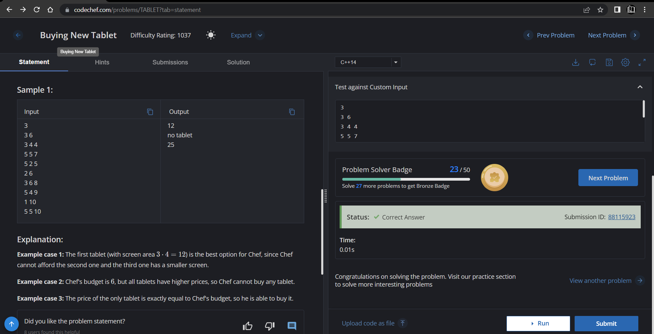

**Understanding about problem:**

* In this task I need to return screen size of tablet which is in budget of Chef and also having large screen.

Note: If you can't understand the problem, feel free to contact us and we'll help you. Please don't copy and paste from anywhere.

ALL THE BEST

Team CP Club